# Overview of Azure compute services

1. Azure compute is an on-demand computing service for running cloud-based applications
2. Provides computing resources such as disks, processors, memory, networking, and operating systems
3. You pay only for the resources you use
4. Azure supports a wide range of computing solutions for development and testing, running applications, and extending your datacentre
5. supports Linux, Windows Server, SQL Server, Oracle, IBM, and SAP
6. Some of the most prominent services are:
   1. **Azure Virtual Machines:** software emulations of physical computers. Include a virtual processor, memory, storage, and networking resources. Create and use VMs in the cloud. Virtual Machines provides infrastructure as a service (IaaS). When you need total control over an operating system and environment, VMs are an ideal choice
   2. **Virtual machine scale sets: U**sed to deploy and manage a set of identical VMs. Are designed to support true autoscale. As demand goes up, more VM instances can be added. As demand goes down, VM instances can be removed.
   3. **Containers and Kubernetes:** Containers are lightweight, virtualized application environments. They’re designed to be quickly created, scaled out, and stopped dynamically.
   4. **App Service:** you can quickly build, deploy, and scale enterprise-grade web, mobile, and API apps running on any platform. App Service is a platform as a service (PaaS) offering.
   5. **Functions:** Ideal when you’re concerned only about the code running your service and not the underlying platform or infrastructure. used when you need to perform work in response to an event eg. REST request.

# Decide when to use Azure Virtual Machines

1. One possible solution to Tailwind Traders’ lack of physical servers is through the use of virtual machines (VMs).
2. VMs are an ideal choice when you need:
   1. Total control over the operating system (OS)
   2. The ability to run custom software
   3. To use custom hosting configurations
3. Azure VM gives you the flexibility of virtualization without having to buy and maintain the physical hardware
4. You still need to configure, update, and maintain the software on the VM.
5. Selecting an image is one of the most important decisions

## **Examples of when to use VMs**

1. **During testing and development:** Quick and easy way to create different OS and application configurations. Delete when not needed.
2. **When running applications in the cloud:**  Ability to run certain applications in the public cloud. Shutting down VMs when you don’t need them or quickly starting them up.
3. **When extending your datacenter to the cloud:** Organization can extend the capabilities of its own on-premises network.
4. **During disaster recovery:**  If a primary datacenter fails, you can create VMs running on Azure to run your critical applications

## **Move to the cloud with VMs**

1. Move from a physical server to the cloud (also known as lift and shift)
2. Just like a physical on-premises server, you must maintain the VM. You update the installed OS and the software it runs

## **Scale VMs in Azure**

1. You can run single VMs for testing, development, or minor tasks.
2. Or you can group VMs together to provide high availability, scalability, and redundancy.
3. Azure VM features include:
   1. **Virtual machine scale sets:** create and manage a group of identical, load-balanced VMs. Centrally manage, configure, and update a large number of VMs in minutes. Build large-scale services for areas such as compute, big data, and container workloads.
   2. **Azure Batch:**  Enables large-scale parallel and high-performance computing (HPC) batch jobs. When you’re ready to run a job, Batch does the following:
      1. Starts a pool of compute VMs for you
      2. Installs applications and staging data.
      3. Runs jobs with as many tasks as you have.
      4. Identifies failures
      5. Requeues work
      6. Scales down the pool as work completes

# Decide when to use Azure App Service

1. Can deploy your application’s front-end websites to Azure App Service
2. App Service enables you to build and host web apps, background jobs, mobile back-ends, and RESTful APIs in the programming language of your choice without managing infrastructure
3. This platform as a service (PaaS) environment

## **Azure App Service costs**

1. You pay for the Azure compute resources your app uses while it processes requests
2. App Service plan determines how much hardware is devoted
3. Plan determines whether it’s dedicated or shared hardware and how much memory

## **Types of app services**

1. Host most common app service styles like:
   1. **Web Apps:** Full support for hosting web apps by using ASP.NET, ASP.NET Core, Java, Ruby, Node.js, PHP, or Python in Windows or Linux
   2. **Api:**  Build REST-based web APIs by using your choice of language and framework. Get full Swagger support. Host API in Azure Marketplace. Consumed via HTTP- or HTTPS.
   3. **WebJobs:** They can be scheduled or run by a trigger. Often used to run background tasks.
   4. **Mobile Apps:** Use to quickly build a back end for iOS and Android apps. You can:
      1. Store mobile app data in a cloud-based SQL database
      2. Authenticate customers against common social providers, such as MSA, Google, Twitter, and Facebook
      3. Send push notifications
      4. Execute custom back-end logic in C# or Node.js
      5. On the mobile app side, there’s SDK support for native iOS and Android, Xamarin, and React native apps
2. App Service handles most of the infrastructure decisions including:
   1. Deployment and management are integrated into the platform
   2. Endpoints can be secured
   3. Sites can be scaled quickly to handle high traffic
   4. The built-in load balancing and traffic manager provide high availability

# Decide when to use Azure Container Instances or Azure Kubernetes Service

1. Still limited to a single operating system per virtual machine
2. If you want to run multiple instances of an application on a single host machine, containers are an excellent choice.

## **What are containers?**

1. Containers are a virtualization environment.
2. Run multiple containers on a single host
3. You don’t manage the operating system for a container
4. Containers are lightweight and designed to be created, scaled out, and stopped dynamically
5. Containers can run side by side
6. Docker the most popular container engine
7. VM virtualize the hardware
8. Containers virtualise the OS
9. With containers, dev environment and prod environment look the same

## **Manage containers**

1. Containers are managed through a container orchestrator
2. Start, stop, and scale out application instances as needed
3. Two ways to manage both Docker and Microsoft-based containers in Azure: Azure Container Instances and Azure Kubernetes Service (AKS).
4. **Azure Container Instances:** offers the fastest and simplest way to run a container in Azure. It’s a platform as a service (PaaS).
5. **Azure Kubernetes Service:** The task of automating, managing, and interacting with a large number of containers is known as orchestration. Is a complete orchestration service for containers.

## **What is Kubernetes?**

1. Handles demands of containers at scale
2. Combines containers and API
3. Manages PODS on a kubernetes cluster node
4. Minimises downtime by moving PODS/Containers went required.
5. Uses Azure storage or Azure Cosmos DB
6. Kubernetes networking allows access Internet, load balancing, isolation and policy driven networks

## **Use containers in your solutions**

1. Containers are often used to create solutions by using a microservice architecture
2. This architecture is where you break solutions into smaller, independent pieces
3. For example, you might split a website into a container hosting your front end, another hosting your back end, and a third for storage
4. Imagine your website back-end has reached capacity but the front end and storage aren’t being stressed. You could:
   1. Scale the back end separately to improve performance
   2. Decide to use a different storage service
   3. Replace the storage container without affecting the rest of the application

## **What is a microservice?**

1. Microservices don’t need to share the same frameworks or language etc
2. Teams can make changes to the microservice without re-deploying the entire application
3. Easily roll back or roll forward an update
4. Bug fixes and new features are less risky
5. Micorservices must be autonomous
6. This provides a layer of fault isolation
7. Microservices commuicate with each other via API
8. Use microservices when:
   1. High release velocity
   2. Highly scalable
   3. Rich domains
   4. Small development teams

# Decide when to use Azure Functions

1. **Azure Function:** Some of your application logic is event driven, your application is waiting for a particular input before it performs any processing. To reduce your costs, you want to avoid having to pay for the time that your application is waiting for input. With that in mind, you’ve decided to investigate Azure Functions to see if it can help.
2. **Serverless computing:** Is the abstraction of servers, infrastructure, and OS
3. Infrastructure isn’t your responsibility
4. Scaling and performance are handled automatically
5. Serverless computing includes:
   1. **Abstraction of servers:** abstracts the servers, you deploy your code, which then runs with high availability
   2. **Event-driven scale:**  Serverless computing is an excellent fit for workloads that respond to incoming events. Such as:
      1. Timers
      2. HTTP, API webhooks
      3. Queues
   3. **Micro-billing:**  Traditional computing bills monthly or annually. With serverless computing, they pay only for the time their code runs.

# Serverless computing in Azure

1. Benefits of serverless computing in Azure:
   1. No infrasture management.
   2. Scalabilty - As your application grows it can handle this
   3. Only pay for what you use
2. Azure has two implementations of serverless compute:
   1. **Azure Functions:** Functions can execute code in almost any modern language
   2. **Azure Logic Apps**: Logic apps are designed in a web-based designer and can execute logic triggered by Azure services without writing any code

## **Azure Functions**

1. When you’re concerned only about the code, Azure Functions is ideal
2. Used when you need to perform work in response to an event, timer or message
3. Functions scale automatically, solid choice when demand is viable
4. Using a VM you incur costs even when the virtual machine is idle
5. With functions you’re only charged for the CPU time
6. Functions can be either stateless or stateful
7. When they’re stateless (the default), they behave as if they’re restarted every time they respond to an event
8. When they’re stateful (called Durable Functions), a context is passed through the function to track prior activity
9. Functions are a key component of serverless computing

## **Azure Logic Apps**

1. Logic apps are similar to functions
2. Both enable you to trigger logic based on an event
3. Functions execute code, logic apps execute workflows
4. Every Azure logic app workflow starts with a trigger, which fires when a specific event happens or when newly available data meets specific criteria
5. Each time the trigger fires, the Logic Apps engine creates a logic app instance that runs the actions in the workflow
6. Actions can also include data conversions and flow controls, such as conditional statements, switch statements, loops, and branching
7. You create logic app workflows by using a visual designer on the Azure portal or in Visual Studio
8. The workflows are persisted as a JSON file with a known workflow schema
9. Azure provides more than 200 different connectors and processing blocks
10. You can also build custom connectors and workflow steps
11. You then use the visual designer to link connectors and blocks together

**Example of how a Logic App would work:**

* Detect the intent of the message with cognitive services.
* Create an item in SharePoint to track the issue.
* Add the customer to your Dynamics 365 CRM system if they aren’t already in your database.
* Send a follow-up email to acknowledge their request.

## **Functions vs. Logic Apps**

1. With Functions, you write code to complete each step
2. With Logic Apps, you use a GUI to define the action
3. Here are some common differences between the two:

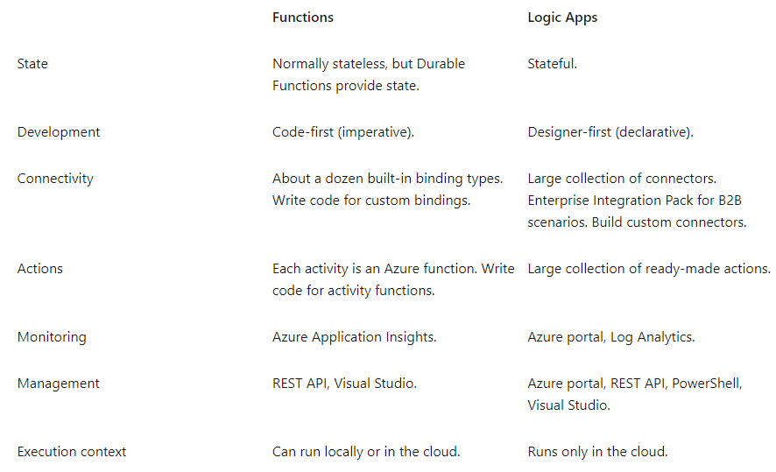

# Decide when to use Azure Virtual Desktop

1. With a team of remote workers, with different OS and devices. A way to rollout tools and minimise costs and to expedite the process Azure Virtual Desktop can be used.

## **What is Azure Virtual Desktop?**

1. Is a desktop and application virtualization service that runs on the cloud
2. Use a cloud-hosted version of Windows from any location
3. Works across devices like Windows, Mac, iOS, Android, and Linux
4. You can also use most modern browsers

## **Why should you use Azure Virtual Desktop?**

1. **Provide the best user experience:** Users have the freedom to connect to Azure Virtual Desktop with any device over the internet. They use a Azure Virtual Desktop client to connect. This could be native application or Azure Virtual Desktop HTML5 web client. user profiles are containerized by using FSLogix. Individual ownership through personal (persistent) desktops. They can add or remove programs without impacting other users on that remote desktop.
2. **Enhance security:** Azure Virtual Desktop provides centralized security management. Enable multifactor authentication to secure user sign-ins. Can also apply granular role-based access controls (RBACs) to users. Data and apps are separated from the local hardware. Risk of confidential data being left on a personal device is reduced. Azure Virtual Desktop also improves security by using reverse connect technology. This connection type is more secure than the Remote Desktop Protocol. We don’t open inbound ports to the session host VMs.

## **What are some key features of Azure Virtual Desktop?**

1. **Simplified management:** You use Azure AD and RBACs to manage access to resources.
2. **Performance management:** Azure Virtual Desktop gives you options to load balance users on your VM host pools. Host pools are collections of VMs with the same configuration assigned to multiple users. For the best performance, you can configure load balancing to occur as users sign in (breadth mode). With breadth mode, users are sequentially allocated across the host pool for your workload.
3. **Multi-session Windows 10 deployment:** The only Windows client-based operating system that enables multiple concurrent users on a single VM.

## **How can you reduce costs with Azure Virtual Desktop?**

1. Azure Virtual Desktop is available to you at no additional cost if you have an eligible Microsoft 365 license
2. Bring your eligible Windows or Microsoft 365 license to get Windows 10 Enterprise and Windows 7 Enterprise desktops and apps at no additional cost.
3. If you’re an eligible Microsoft Remote Desktop Services Client Access License customer, Windows Server Remote Desktop Services desktops and apps are available at no additional cost.
4. Buy one-year or three-year Azure Reserved Virtual Machine Instances to save you up to 72 percent versus pay-as-you-go pricing

Top of Form

Which Azure compute resource can be deployed to manage a set of identical virtual machines?



#### Virtual machine scale sets

That’s correct. Virtual machine scale sets let you deploy and manage a set of identical virtual machines.



#### Virtual machine availability sets



#### Virtual machine availability zones

2.

Which of the following services should be used when the primary concern is to perform work in response to an event (often via a REST command) that needs a response in a few seconds?



#### Azure Functions

That’s correct. Azure Functions is used when you need to perform work in response to an event (often via a REST request), timer, or message from another Azure service, and when that work can be completed quickly, within seconds or less.



#### Azure App Service



#### Azure Container Instances

3.

Your company has a team of remote workers that need to use Windows-based software to develop your company’s applications, but your team members are using various operating systems like macOS, Linux, and Windows. Which Azure compute service would help resolve this scenario?



#### Azure App Service



#### Azure Virtual Desktop

That’s correct. Azure Virtual Desktop enables your team members to run Windows in the cloud, with access to the required applications for your company’s needs.



#### Azure Container Instances

1 out of 3 questions is incorrect. Please correct question 3.

Bottom of Form

## Azure Virtual Network fundamentals

## **What is Azure virtual networking?**

1. Azure virtual networks enable Azure resources, such as VMs, web apps, and databases, to communicate with each other
2. Azure network is a set of resources that links other Azure resources
3. **Azure virtual networks provide the following key networking capabilities:** Isolation and segmentation, Internet communications, Communicate between Azure resources, Communicate with on-premises resources, Route network traffic, Filter network traffic, Connect virtual networks

## **Isolation and segmentation**

* When you set up a virtual network, you define a private IP address space by using either public or private IP address ranges
* You can use the name resolution service that’s built in to Azure
* Can use either an internal or an external DNS server

## **Internet communications**

* A VM in Azure can connect to the internet by default
* Enable incoming connections from the internet by defining a public IP address or a public load balancer
* VM management via the Azure CLI, Remote Desktop Protocol, or Secure Shell

## **Communicate between Azure resources**

* Enable Azure resources to communicate securely in two ways:
  1. **Virtual networks:** Connect not only VMs but other Azure resources, such as the App Service Environment for Power Apps, Azure Kubernetes Service, and Azure virtual machine scale sets
  2. **Service endpoints:**  service endpoints to connect to other Azure resource types, such as Azure SQL databases and storage accounts

## **Communicate with on-premises resources**

* • There are three mechanisms for you to achieve this connectivity:
  1. **Point-to-site virtual private networks:** Connection is from a computer outside your organization, back into your corporate network
  2. **Site-to-site virtual private networks:** A site-to-site VPN links your on-premises VPN device or gateway to the Azure VPN gateway in a virtual network
  3. **Azure ExpressRoute:** Environments where you need greater bandwidth and even higher levels of security

## **Route network traffic**

* You also can control routing and override those settings, as follows:
  1. **Route tables:** Allows you to define rules about how traffic should be directed
  2. **Border Gateway Protocol:** Works with Azure VPN gateways or ExpressRoute

## **Filter network traffic**

* • Filter traffic between subnets by using the following approaches:
  1. **Network security groups:**  A network security group is an Azure resource that can contain multiple inbound and outbound security rules
  2. **Network virtual appliances:** Carries out a particular network function, such as running a firewall or performing wide area network (WAN) optimization

## **Connect virtual networks**

* Link virtual networks together by using virtual network peering
* Peering enables resources in each virtual network to communicate with each other
* UDR is user-defined Routing
* UDR is a significant update to Azure’s Virtual Networks - allowing for greater control over network traffic flow.

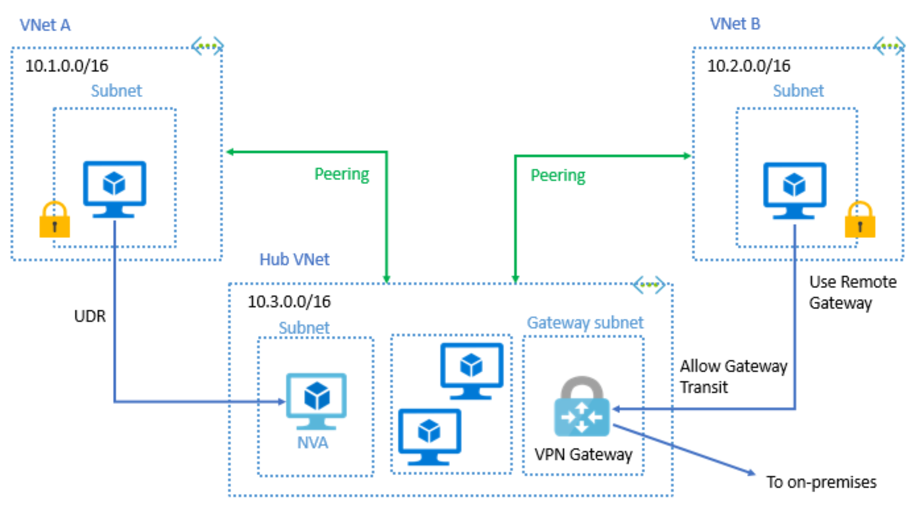

# Azure Virtual Network settings

1. You can create and configure Azure Virtual Network instances from the Azure portal, Azure PowerShell on your local computer, or Azure Cloud Shell.

## **Create a virtual network**

1. **Network name**: name must be unique in your subscription
2. **Address space**: define the internal address space in Classless Interdomain Routing (CIDR) format
3. **Subscription**: Only if you have multiple subscriptions
4. **Resource group:**
5. **Location** : where you want the virtual network to exist
6. **Subnet**: can create one or more subnets
7. **DDoS protection:**  Basic or Standard DDoS protection. Standard DDoS protection is a premium service.
8. **Service endpoints:** include Azure Cosmos DB, Azure Service Bus, Azure Key Vault

## **Define additional settings**

1. **Network security group:** filter the type of network traffic
2. **Route table:** Azure automatically creates a route table for each subnet

## **Configure virtual networks**

1. Make changes in Azure portal or Powershell commands

# Azure VPN Gateway fundamentals

1. VPNs use an encrypted tunnel within another network
2. Typically deployed to connect two or more trusted private networks to one another over an untrusted network (typically the public internet)
3. Traffic is encrypted preventing eavesdropping or other attacks

## **VPN gateways**

1. Azure VPN Gateway instances are deployed in Azure Virtual Network instances
2. Enable the following connectivity:
   1. Connect on-premises datacenters to virtual networks through a **site-to-site connection**
   2. Connect individual devices to virtual networks through **a point-to-site connection**
   3. Connect virtual networks to other virtual networks through a **network-to-network connection**
3. You can deploy only one VPN gateway in each virtual network
4. But you can use one gateway to connect to multiple locations
5. When you deploy a VPN gateway, you specify the VPN type: either**policy-based or route-based**
6. Difference between these two types of VPNs is how traffic to be encrypted
7. Both types of VPN gateways use a pre-shared key as the only method of authentication
8. Both types also rely on Internet Key Exchange (IKE) in either version 1 or version 2 and Internet Protocol Security (IPSec)

## **Policy-based VPNs**

1. Specify statically the IP address of packets that should be encrypted
2. Device evaluates every data packet against those sets of IP addresses
3. Key features of policy-based VPN:
   1. Support for IKEv1 only
   2. Use of static routing
   3. Must be used in specific scenarios that require them, such as for compatibility with legacy on-premises VPN devices

## **Route-based VPNs**

1. Used when defining which IP addresses are behind each tunnel is too cumbersome
2. IPSec tunnels are modeled as a network interface or virtual tunnel interface
3. IP routing decides which one of these tunnel interfaces
4. Are the preferred connection method for on-premises devices
5. More resilient to topology changes
6. Use a route-based VPN gateway when:
   1. Connections between virtual networks
   2. Point-to-site connections
   3. Multisite connections
   4. Coexistence with an Azure ExpressRoute gateway
7. Key Features:
   1. Supports IKEv2
   2. Uses any-to-any (wildcard) traffic selectors
   3. Can use dynamic routing protocols

## **VPN gateway sizes**

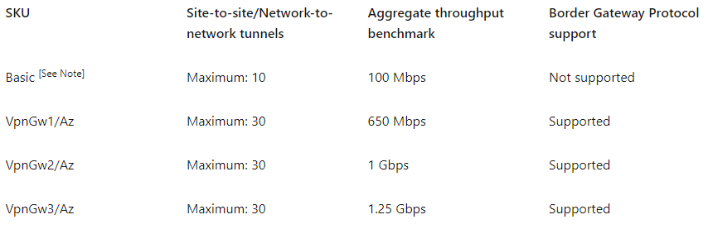

## **Deploy VPN gateways**

1. Azure resources before you can deploy an operational VPN gateway:
   1. **Virtual network**
   2. **GatewaySubnet**
   3. **Public IP address**
   4. **Local network gateway**
   5. **Virtual network gateway**
   6. **Connection**

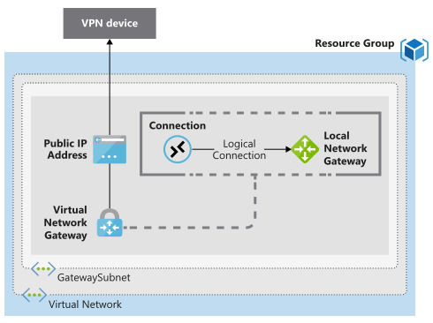

## **Required on-premises resources**

1. To connect your datacenter to a VPN gateway you will need:
   1. A VPN device that supports policy-based or route-based VPN gateways
   2. A public-facing (internet-routable) IPv4 address

## **High-availability scenarios**

1. There are several ways to ensure you have a fault-tolerant configuration:
   1. **Active/standby:** By default, VPN gateways are deployed as two instances in an active/standby. When planned maintenance or unplanned disruption the standby instance automatically assumes responsibility. Connections are interrupted during this failover, but they’re typically restored within a few seconds.
   2. **Active/active:**  Support for the BGP routing protocol. You can extend the high availability by deploying an additional VPN device on-premises
   3. **ExpressRoute failover:** Configure a VPN gateway as a secure failover path for ExpressRoute connections. ExpressRoute circuits have resiliency built in. Are not immune to physical problems.
   4. **Zone-redundant gateways:** In regions that support availability zones, VPN gateways and ExpressRoute gateways can be deployed in a zone-redundant configuration. Configuration brings resiliency, scalability, and higher availability to virtual network gateways. These gateways require different gateway SKUs and use Standard public IP addresses instead of Basic public IP addresses.

# Azure ExpressRoute fundamentals

1. ExpressRoute lets you extend your on-premises networks into the Microsoft cloud
2. Establish connections to Microsoft cloud services, such as Microsoft Azure and Microsoft 365.
3. Connectivity can be from an any-to-any (IP VPN) network, a point-to-point Ethernet network, or a virtual cross-connection through a connectivity provider at a colocation facility
4. ExpressRoute connections don’t go over the public Internet
5. Allows ExpressRoute connections to offer more reliability, faster speeds, consistent latencies, and higher security than typical connections over the Internet
6. Open Systems Interconnection (OSI) model:
   1. **Layer 2 (L2)**: This layer is the Data Link Layer
   2. **Layer 3 (L3)**: This layer is the Network Layer

## **Features and benefits of ExpressRoute**

1. Benefits to using ExpressRoute:
   1. **Layer 3 connectivity:** provides Layer 3 (address-level) connectivity. Can be point-to-point or virtual cross connections
   2. **Built-in redundancy:** Ensures that connections established with Microsoft are highly available
   3. **Connectivity to Microsoft cloud services:** Direct access to Microsoft Office 365, Microsoft Dynamics 365, Azure Compute Services and Azure Cloud Services
   4. **Across on-premises connectivity with ExpressRoute Global Reach:** To exchange data across your on-premises sites by connecting your ExpressRoute circuits. You can connect your private datacenters through two ExpressRoute.
   5. **Dynamic routing:** Uses the Border Gateway Protocol (BGP).
   6. **Connection uptime SLA.**
   7. **QoS support for Skype for business**

## **ExpressRoute connectivity models**

1. **Colocation at a cloud exchange:** ProvidesLayer 2 and Layer 3**.** If your datacenter is colocated at a cloud exchange such as an ISP, you can request a virtual cross-connection to the Microsoft cloud
2. **Point-to-point Ethernet connection:** ProvidesLayer 2 and Layer 3. If you have an on-premises datacenter, you can use a point-to-point Ethernet link to connect to Microsoft
3. **Any-to-any networks:** You can integrate your wide area network (WAN) with Azure. offer Layer 3 connectivity

## **Security considerations**

1. With ExpressRoute, your data doesn't travel over the public internet, so it's not exposed to the potential risks associated with internet communications
2. ExpressRoute is a private connection from your on-premises infrastructure to your Azure
3. DNS queries, certificate revocation list checking, and Azure Content Delivery Network requests are still sent over the public internet.

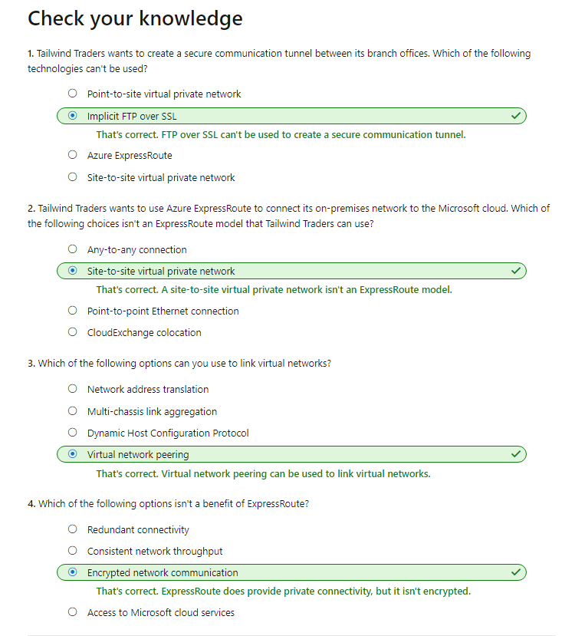

# Azure Storage account fundamentals

1. [Azure Storage](https://azure.microsoft.com/product-categories/storage), which is a service that you can use to store files, messages, tables, and other types of information
2. Clients such as websites, mobile apps, desktop applications, and many other types of custom solutions can read data from and write data to Azure Storage
3. Azure Storage is also used by **infrastructure as a service** virtual machines, and **platform as a service** cloud services.
4. Blob storage for massive unstructured data. Ideal for images or documents to browser. Video and audio.
5. To begin using Azure Storage, you first create an Azure Storage account to store your data objects
6. ou can create an Azure Storage account by using the Azure portal, PowerShell, or the Azure CLI
7. A storage account provides a unique namespace for your Azure Storage data, that's accessible from anywhere in the world over HTTP or HTTPS
8. Data in this account is secure, highly available, durable, and massively scalable
9. Check Azure Storage Video again

## **Disk storage fundamentals**

1. Disk Storage provides disks for Azure virtual machines
2. Applications and services can access these disks, as in on-premises scenarios
3. Disk Storage allows data to be persistently stored and accessed
4. Get solid-state drives (SSDs) and traditional spinning hard disk drives (HDDs),
5. Premium SSD disks for mission-critical production applications
6. Standard SSD and HDD disks for less critical workloads
7. Ultra disks for data-intensive workloads such as SAP

## **Azure Blob storage fundamentals**

1. Azure Blob Storage is an object storage solution for the cloud
2. It can store massive amounts of data, such as text or binary data
3. Azure Blob Storage is unstructured, meaning that there are no restrictions on the kinds of data
4. Blob Storage can manage:
   1. Thousands of simultaneous uploads
   2. Massive amounts of video data
   3. Constantly growing log files
   4. Reached from anywhere with an internet connection
5. Blobs aren't limited to common file formats
6. **Advantage:** Developers don’t have to think about or manage disks
7. Blob Storage is ideal for:
   1. Serving images or documents directly to a browser
   2. Storing files for distributed access
   3. Streaming video and audio
   4. Storing data for backup and restore, disaster recovery, and archiving
   5. Storing data for analysis by an on-premises or Azure-hosted service
   6. Storing up to 8 TB of data

## **Azure Files fundamentals**

1. Azure Files offers fully managed file shares in the cloud
2. Accessible via Server Message Block and Network File System (preview) protocols
3. Typical usage scenarios would be to share files anywhere in the world, diagnostic data, or application data sharing
4. Use Azure Files for the following situations:
   1. Azure files makes it easier to migrate applications that share data to Azure
   2. If you mount the Azure file share to the same drive letter that the on-premises application uses, there should be minimal changes
   3. Store configuration files on a file share and access them from multiple VMs.
   4. Write data to a file share, and process or analyze the data later
5. You can also use Shared Access Signature (SAS) tokens to allow access to a private asset for a specific amount of time

## **Understand Blob access tiers**

1. Data stored in the cloud can be different based on how it's **generated**, **processed**, and **accessed** over its lifetime
2. To accommodate these different access needs, Azure provides several access tiers
3. You can use to balance your storage costs with your access needs
4. The available access tiers include:
   1. **Hot access tier**: data that is accessed frequently, i.e. Website
   2. **Cool access tier**:  data that is infrequently accessed and stored for at least 30 days, i.e. customer invoices
   3. **Archive access tier**:  data that is rarely accessed and stored for at least 180 days
5. **Blob access tiers considerations:**
   1. Only the hot and cool access tiers can be set at the account level. The archive access tier isn't available at the account level
   2. Hot, cool, and archive tiers can be set at the blob level
   3. Data in the cool access tier can tolerate slightly lower availability, but still requires high durability, retrieval latency, and throughput characteristics similar to hot data
   4. Archive storage offers the lowest storage costs, but also the highest costs to rehydrate and access data.

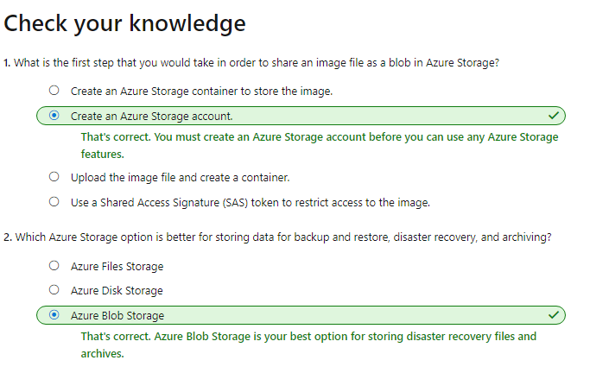

# Explore Azure Cosmos DB

1. Azure Cosmos DB is a globally distributed, multi-model database service
2. Fast, single-digit-millisecond data access by using any one of several popular APIs
3. Service level agreements for throughput, latency, availability, and consistency guarantees
4. Supports schema-less data
5. Azure Cosmos DB stores data in atom-record-sequence (ARS) format
6. This data can be abstracted and projected as an API
7. Developers can use SQL, MongoDB, Cassandra, Tables, and Gremlin

## **Explore Azure SQL Database**

1. Is a relational database
2. SQL Database is a high-performance, reliable, fully managed, and secure database
3. Platform as a service (PaaS) database engine
4. Handles most of the database management functions, such as upgrading, patching, backups, and monitoring, without user involvement
5. Allows relational data and non-relational structures, such as graphs, JSON, spatial, and XML

## **Migration**

1. You can migrate your existing SQL Server databases with minimal downtime by using the Azure Database Migration Service
2. Microsoft Data Migration Assistant can generate assessment reports that provide recommendations

# Explore Azure database for MySQL

1. Azure Database for MySQL is a relational database service in the cloud
2. Also has service level agreement from Azure
3. Azure Database for MySQL delivers:
   1. Built-in high availability with no additional cost
   2. Predictable performance and inclusive, pay-as-you-go pricing
   3. Scale as needed, within seconds
   4. Ability to protect sensitive data at-rest and in-motion
   5. Automatic backups
   6. Enterprise-grade security and compliance
4. These capabilities require almost no administration, and all are provided at no additional cost
5. Migrate your existing MySQL databases

# Explore Azure Database for PostgreSQL

1. Azure Database for PostgreSQL is a relational database service in the cloud
2. Azure Database for PostgreSQL delivers the following benefits:
   1. Built-in high availability compared to on-premises resources
   2. Simple and flexible pricing
   3. Scale up or down as needed
   4. Adjustable automatic backups
   5. Enterprise-grade security
3. Azure Database for PostgreSQL is available in two deployment options: **Single Server** and **Hyperscale (Citus)**.

## **Single Server**

1. Focus on rapid application development and accelerating your time to market, rather than having to manage virtual machines and infrastructure
2. Single Server deployment option offers three pricing tiers: Basic, General Purpose, and Memory Optimized

## **Hyperscale (Citus)**

1. Horizontally scales queries across multiple machines by using sharding
2. Query engine parallelizes incoming SQL queries across these servers for faster responses on large datasets

# Explore Azure SQL Managed Instance

1. Azure SQL Managed Instance is a platform as a service (PaaS) database engine
2. You'll also be able to protect your data with automated backups and a configurable backup retention period
3. Azure SQL Managed Instance provides several options that might not be available to Azure SQL Database. For example DB migration with Cyrillic characters for collation

## **Migration**

1. Azure SQL Managed Instance makes it easy to migrate your on-premises data on SQL Server to the cloud using the Azure Database Migration Service (DMS) or native backup and restore

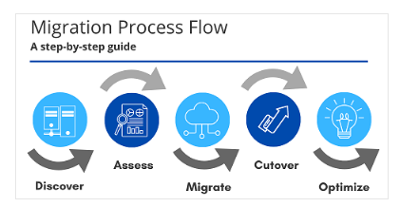

# Explore big data and analytics

1. Big data = large volumes of data
2. Azure supports a broad range of technologies and services:
   1. **Azure Synapse Analytics**
      1. Limitless analytics service that brings together enterprise data warehousing and big data analytics
      2. Query data using either serverless or provisioned resources at scale
   2. **Azure HDInsight**
      1. Fully managed, open-source analytics service
      2. Cloud service that makes it easier, faster, and more cost-effective to process massive amounts of data
      3. You can run popular open-source frameworks and create cluster types such as [Apache Spark](https://docs.microsoft.com/en-us/azure/hdinsight/spark/apache-spark-overview), [Apache Hadoop](https://docs.microsoft.com/en-us/azure/hdinsight/hadoop/apache-hadoop-introduction), [Apache Kafka](https://docs.microsoft.com/en-us/azure/hdinsight/kafka/apache-kafka-introduction), [Apache HBase](https://docs.microsoft.com/en-us/azure/hdinsight/hbase/apache-hbase-overview), [Apache Storm](https://docs.microsoft.com/en-us/azure/hdinsight/storm/apache-storm-overview), and [Machine Learning Services](https://docs.microsoft.com/en-us/azure/hdinsight/r-server/r-server-overview)
      4. HDInsight also supports a broad range of scenarios such as extraction, transformation, and loading (ETL), data warehousing, machine learning, and IoT
   3. **Azure Databricks**
      1. Helps you unlock insights from all your data and build artificial intelligence solutions
      2. Azure Databricks supports Python, Scala, R, Java, and SQL
   4. **Azure Data Lake Analytics**
      1. Is an on-demand analytics job service that simplifies big data
      2. Instead of deploying, configuring, and tuning hardware, you write queries to transform your data and extract valuable insights

